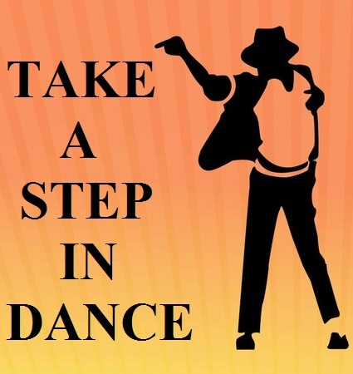

Dance is the Hidden Language of the Sole of the Body.
When You Dance , your purpose is nai to get to a certain place on the floor . It’s to enjoy each step along the way
The Step Cell is one of the most active as well as among the best cells of SRMGPC. This cell, in our college, originated in the year 2005. Since then it’s been developing with flying colors. Every year there are tremendously so many new talents which become part of this family and then they spread the magic of their talent in front of everyone.
Members List
Faculty Coordinators | : | - Mr. Saumrita Mishra [EC]  - Abhiruchi Pandey[MBA] | - Ms. Sandhya Pandey  - Ms. Mitti [EI]  3. Ms. AbhiruchiPandey[CE]
Coordinators | : | Prateek Dubey  B.Tech EN 3rdyr  Vaishali Sinha  B.Tech IT 3rdyr  Hemant Mahour  B.Tech CE 3rdyr | Snehil Saxena  B.Tech CS 3rdyr  Disha Srivastava  B.Tech CE 3rdyr
Assistant Coordinators | : | Gaurav Singh  B.Tech EN 2ndyr  Sagar Srivastava  B.Tech CS 2nd yr | Richa Trivedi  B.Tech EC 2nd yr  Somya Singh  B.Tech EE2nd yr  Pratyusha  B.Tech EC 2nd yr
Veteran Coordinators | : | Prerit Saxena  B.Tech CE 4thyr | Divya Dixit  B.Tech EN 4thyr

EVENT LIST
Competitive Events

- EKLA A SOLO SOLE (Solos for Girls & Boys )
- Time Limit: 3 minutes for each
- Props are allowed

- JITTERBUG (Group Dance)
- Time Limit: 4 minutes for each
- Max. members 8
- Props are allowed

GENEREAL RULES for Competitive Events

- Only 10 entries per competitive event from a college will be accepted.
- Soundtrack given by the participants should be in mp3 format.
- Participants are required to bring their track in pendrive and give to the coordinators before the events are started.
- If failed to perform in the 1st attempt, no 2nd attempt will be provided to the contestants in any of the competitive events.
- Decision of the Judges and the Organizing committee will be final and cannot be challenged.

CONTACTDETAILS
Mr. Saumrita Mishra : 9454265555
(Professor, SRMGPC)

:
(Coordinator)

:8090464941
(Coordinator)

